|  |
| --- |
| 31/5/2024 |

|  |
| --- |
| NABIL RAAD |

# TITLE: ROBOTIC VISION

ABOUT: Graduation project proposal

Instructor name: MR. ABD ALRAHMAN JABER

## INTRODUCTION

[This proposal outlines the development of a cutting-edge robotic vision system example, designed to interpret lip and body movements, facilitating communication with individuals who are deaf or hard of hearing/speaking, supporting safety systems in automotive industry to keep the driver eye on the road, adding smart options in the home automated systems...

The project aims to integrate advanced image processing techniques with machine learning algorithms to create a robust system capable of understanding a wide range of body gestures and speech-related movements.

By leveraging robotic vision, we can create an automated system that enhances the accuracy and availability of this form of communication.

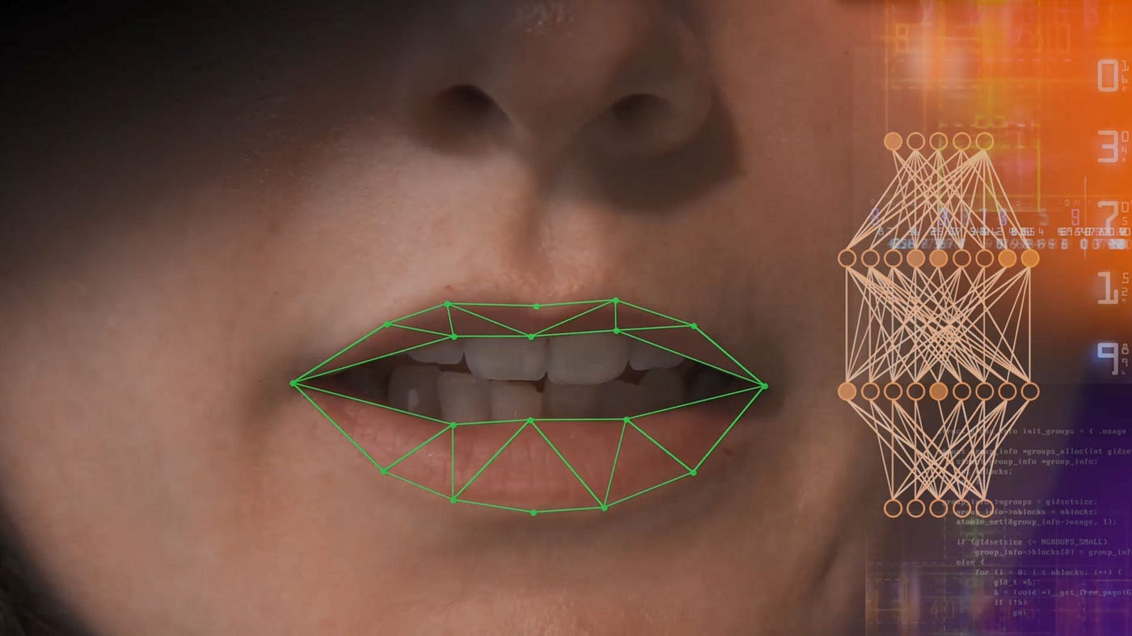

**Objectives**:

* Develop a real-time lipreading algorithm
* Create order detection system by body movement
* can be integrated into existing communication smart systems platforms.

**Methodology**:

* Utilize OpenCV for image processing and facial feature extraction.
* Implement deep learning models for gesture recognition and lip movement interpretation.
* A prototype that demonstrates the feasibility of robotic vision for lipreading and body sign detection
* Sharing the code in a platform that can be used for educational purposes and real-world applications.
* A step towards more inclusive communication technologies.

## DATA

[DATA SOURCE: There is two types of data in this project

1-self collected data: self-collecting data frames by video recording

2-downlouded data [mpg files-ALIGN files]: recorded videos of a character with alignments

1000 videos

LINK:

<https://spandh.dcs.shef.ac.uk//gridcorpus/>

## LIBRARIES and MODULES

TensorFlow -matplotlib - NumPy -Subprocess- time

mediapipe- imageio- gdown-streamlit-cv2-os- typing

